
BMCS2003 • ARTIFICIAL INTELLIGENCE • SESSION 202605
TAR UMT University
Inquiry Chatbot
Dual-Approach Design and Leakage-Free Evaluation of a Dialogflow ES Configuration and a Local TF-IDF + Logistic Regression Pipeline

PREPARED BY Member 1: [TO BE PROVIDED] | Student ID: [TO BE PROVIDED]
Member 2: [TO BE PROVIDED] | Student ID: [TO BE PROVIDED]
TUTORIAL GROUP [TO BE PROVIDED]
TUTOR [TO BE PROVIDED]
SUBMISSION DEADLINE 28 August 2026, before 12:00 p.m.
EVALUATION SNAPSHOT 2026-08-24T18:02:56.633862

Document control and report map
Evidence boundary All reported model values are read from data/evaluation_results.json. Member 1 values describe a local, train-only Dialogflow-style simulator and are not cloud Dialogflow metrics. No user-satisfaction percentage is claimed. BLEU and ROUGE remain N/A unless the evaluation artifact contains scores derived from independent reference answers.
Table 1: Document control
Field | Recorded value
Report builder | tools/build_final_report.py
Output | AI Report - Final.docx
Evaluation source | data/evaluation_results.json
Evaluation generated at | 2026-08-24T18:02:56.633862
Document built at | 2026-08-24T18:17:09+08:00
Identifying details | Member names, IDs, tutorial group, and tutor remain [TO BE PROVIDED].

Report map
- Executive summary and rubric traceability
- 1. Introduction
- 2. Related Work
- 3. Methodology
- 4. Results and Discussion
- 5. Conclusion, References and Sources
- Appendices A–F: contributions, reproducibility, survey, authentic evidence, and two plagiarism forms
The five numbered sections mirror the five Documentation Assessment Rubric items in Appendix 1 of the assignment specification.

Executive summary
This project addresses repetitive and fragmented university enquiries by designing a task-oriented chatbot for TAR UMT information. Two development approaches are represented: a Dialogflow ES configuration path and a local Python path. The local path cleans and lemmatises queries with NLTK, extracts character-boundary TF-IDF features (3–5 character n-grams), and applies balanced multinomial Logistic Regression (C = 30, max_iter = 2000) with a 0.20 confidence threshold. Low-confidence queries return a controlled fallback and can be logged for human review.
The current evidence snapshot uses a stratified 80/20 split with random_state = 42, 342 training examples, 86 held-out examples, and 0 cleaned-text overlaps between partitions. The highest held-out accuracy in the recorded comparison is 76.74% for Baseline 2 (Linear SVM). Member 2 records 74.42% accuracy, 0.7626 weighted F1, 87.21% coverage, and 12.79% fallback rate. These values demonstrate the present prototype's limitations rather than a production-ready result.
Response-generation scoring status is Independent reference test (14 cases); intent accuracy=0.7857; coverage=0.9286. The verified feedback file contains 0 record(s); therefore user-satisfaction findings are N/A at this snapshot. Appendix C supplies the survey instrument and analysis protocol for a future genuine study.

Rubric traceability
Table 2: Documentation-rubric traceability
Rubric item | Primary evidence in this report | Good-band intent
Introduction | Background, problem, gap, aligned objectives, scope, significance | Comprehensive and justified
Related Work | Critical comparison of university chatbots, Dialogflow, local ML, and evaluation | Evaluated, not merely described
Methodology | Architecture, dataset provenance, algorithms, split, metrics, and validity controls | Logical, reproducible, justified
Results & Discussion | Dynamic tables and charts, confusion analysis, implications, limitations | Evidence-led interpretation
Conclusion & References & Source | Achievements, limitations, future work, APA references, source inventory | Complete and academically transparent

1. Introduction

1.1 Background and context
University applicants and students routinely ask recurring questions about programmes, admissions, fees, academic calendars, accommodation, facilities, student affairs, and contact channels. The answers may exist on official pages, but users must still identify the correct page, interpret institutional terminology, and verify that the information is current. A task-oriented FAQ chatbot can shorten this search path by mapping a natural-language query to a controlled intent and then returning a curated answer or an official source link.
Campus chatbots are a credible application area rather than a purely technical exercise. Ranoliya et al. (2017) demonstrated a university FAQ chatbot, while Dibitonto et al. (2018) situated a virtual assistant within student university life. Dialogflow ES provides managed concepts for agents, intents, entities, contexts, fulfilment, and integrations (Google Cloud, n.d.). A local statistical classifier offers a contrasting path whose data flow, features, decision threshold, and errors can be inspected in the repository.

1.2 Problem statement
The practical problem is not simply to return an answer when a familiar phrase is entered. The system must recognise paraphrases across many closely related university intents, reject low-confidence queries safely, preserve the provenance of factual answers, and provide evidence that its reported metrics were obtained without training–test leakage. Closely related labels—such as admission versus admission documents, location versus campus map, and facilities versus sports—make the task difficult when each intent has only a small number of examples.
A second problem is evidence quality. A configured Dialogflow agent, a local approximation of Dialogflow-style pattern matching, and a deployed local classifier are different systems. Reporting an offline simulator score as cloud accuracy would invalidate the comparison. Likewise, BLEU, ROUGE, and satisfaction statistics require independent references or genuine respondents; template self-comparison and invented responses are not acceptable evidence.

1.3 Research gap
The reviewed studies establish the usefulness of university chatbots and the importance of selecting an appropriate development platform, but they do not provide a leakage-free, same-split comparison for this repository's TAR UMT inquiry taxonomy. This project therefore focuses on an auditable comparison in which the evaluation boundary is explicit: a train-only local Dialogflow-style simulator, the deployed-configuration local Logistic Regression model, and two classical baselines are tested on the same held-out queries. Cloud Dialogflow performance remains a separate validation task requiring authentic console or API evidence.

1.4 Objectives
- Design a university FAQ chatbot that covers major TAR UMT inquiry categories and returns controlled, source-aware responses.
- Represent two distinct member approaches: a Dialogflow ES agent configuration and an offline Python intent classifier.
- Implement the local classifier with deterministic preprocessing, character-boundary TF-IDF features, balanced Logistic Regression, confidence gating, and fallback logging.
- Evaluate intent recognition on a fixed stratified held-out split using accuracy, weighted precision, weighted recall, weighted F1, coverage, fallback rate, and confusion analysis.
- Define valid protocols for response quality and user satisfaction, and report N/A until independent evidence is available.
- Deliver reproducible source code, evaluation artifacts, charts, and documentation that can be regenerated from the repository.

1.5 Scope and significance
The current source inventory contains 36 semantic intents and 432 raw training phrases in data/intents.json. The chatbot is English-first, single-turn, and task-oriented. Responses are selected from controlled templates rather than generated freely. This scope supports predictable answers and reduces hallucination risk, but it does not replace official TAR UMT pages or staff advice. Time-sensitive fees, dates, policies, and contact details must be verified at the linked official source.
The project is significant in three ways. For users, it offers a consistent entry point to common information. For administrators, fallback logs expose unanswered demand that can guide dataset maintenance. For AI study, the project demonstrates how thresholding, data provenance, and evaluation design can matter as much as the choice of classifier.
Success criterion A working prototype is necessary but not sufficient. Success means that system claims remain traceable to code, data, and authentic test evidence, and that limitations are disclosed where the current scores are weak.

2. Related Work

2.1 University FAQ and campus assistants
Ranoliya et al. (2017) presented a chatbot for university-related FAQs, illustrating the fit between structured institutional questions and intent/pattern-oriented interaction. Its relevance to this project is the bounded FAQ domain; its limitation for the present study is that a system that performs well on known patterns may still generalise poorly to held-out paraphrases. Dibitonto et al. (2018) designed LiSA as a campus virtual assistant to support students in university life. That work broadens the design question from classification alone to the student's situated experience and reinforces the need for usable, context-appropriate responses.

2.2 Platform-based and local development
Dialogflow ES is a managed natural-language-understanding platform for conversational interfaces. Its agent model organises intents, entities, responses, fulfilment, contexts, and integrations (Google Cloud, n.d.). This can accelerate configuration and integration, but the trained cloud service is externally managed and must be evaluated through its real console or API. A local simulator can exercise repository patterns and provide a transparent baseline, but it cannot stand in for Google's NLU.
Pérez-Soler et al. (2021) frame chatbot development as a tool-selection problem. Their comparison-oriented perspective is useful because the right choice depends on requirements such as deployment control, integration, language support, cost, and maintainability. The local TF-IDF pipeline used here is deliberately inspectable and offline-capable. Character-boundary features improve tolerance to small spelling and word-form variations, but they still require representative data and do not supply semantic understanding.

2.3 Evaluation of classification and responses
Accuracy alone can obscure minority-class behaviour in a multi-intent dataset. Weighted precision, recall, and F1 summarise class-level outcomes while preserving class prevalence; the confusion matrix shows which labels are exchanged. Coverage and fallback rate are also essential for a thresholded chatbot because an apparently cautious model can improve the quality of answered cases by declining many inputs.
BLEU measures n-gram precision with a brevity penalty (Papineni et al., 2002), while ROUGE includes recall-oriented overlap measures (Lin, 2004). Both require candidate outputs and independent reference answers. For a retrieval-style chatbot with template responses, comparing a selected template against the same template bank would be circular. The present report therefore displays N/A when independent reference scoring is absent and treats human judgement as a complementary future measure.
Table 3: Critical comparison of prior work and the present study
Source | Contribution | Relevant limitation or trade-off | Design implication here
Ranoliya et al. (2017) | University FAQ chatbot | Pattern success need not imply paraphrase generalisation | Use a held-out split and confusion analysis
Dibitonto et al. (2018) | Campus assistant designed around student life | User experience extends beyond classifier accuracy | Include authentic usability protocol
Pérez-Soler et al. (2021) | Framework for choosing chatbot tools | No single tool dominates every deployment criterion | Separate cloud configuration from local ML evidence
Google Cloud (n.d.) | Dialogflow ES agent, intent, entity, fulfilment, and integration concepts | Cloud behaviour must be tested in the actual service | Do not label a local simulator score as cloud accuracy
Papineni et al. (2002); Lin (2004) | Automatic text-overlap metrics | Scores depend on independent references and do not establish factuality | Report N/A until a valid reference test is executed

2.4 Synthesis and justification
The literature supports a dual-approach project but also exposes the main risk: unlike systems can be compared as if their evidence were equivalent. The present methodology addresses that risk by identifying each execution path, using identical held-out queries only for local evaluation components, recording coverage alongside accuracy, and retaining cloud validation as an explicit evidence gap. This makes the comparison more cautious but more defensible.

3. Methodology

3.1 Research design and requirements mapping
The project follows a design–build–evaluate workflow. Requirements were translated into a bounded FAQ scenario, two development paths, an intent dataset, controlled response templates, a user interface, and a reproducible evaluation harness. The evaluation is observational: it reports current prototype behaviour and does not claim statistical generalisation beyond the held-out sample.
Table 4: Chatbot-assignment requirement mapping
Assignment requirement | Repository implementation | Evidence status
Real-life chatbot scenario | TAR UMT FAQ and student-information assistant | Implemented
Background study | Section 2 compares university chatbots, tools, and metrics | Documented
Development approach | Dialogflow ES configuration artifacts plus local Python ML | Artifacts present; cloud run needs authentic evidence
Different member solutions | Member 1 configuration/simulator track; Member 2 TF-IDF + LR track | Contribution ownership must be confirmed
Intent-recognition testing | Leakage-free split, four-model metrics, confusion analysis | Measured
Response relevancy/quality | Independent-reference protocol | Measured from 14 cases
User satisfaction | Appendix C instrument and analysis plan | N/A; 0 verified record(s) currently

3.2 System architecture
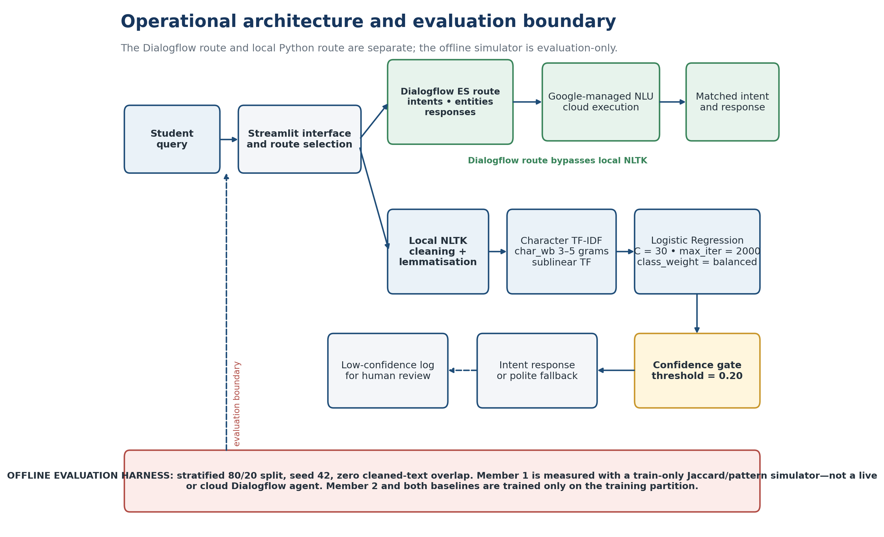
Figure 1: Operational architecture and offline-evaluation boundary
The architecture distinguishes operation from evaluation. On the Dialogflow path, the user query is sent to the configured Google service; it does not first pass through the local NLTK pipeline. On the local path, preprocessing, vectorisation, classification, thresholding, response retrieval, and fallback logging execute within Python. The evaluation harness creates the train/test split and constructs the local models from training examples only.

3.3 Dataset, provenance, and representation
Table 5: Dataset inventory and evaluation snapshot
Artifact or quantity | Current value | Interpretation
data/intents.json | 36 semantic intents; 432 raw phrases; 36 response templates | Current source inventory
Evaluation rows | 428 | Canonical rows recorded when evaluation_results.json was generated
Training partition | 342 | 80% stratified; models fit only here
Held-out partition | 86 | 20% stratified; used for classification metrics
Cleaned-text overlap | 0 | Expected to be zero
Labels in confusion matrix | 36 semantic intents plus fallback outcome | Fallback is an outcome, not a training intent

Canonicalisation note The source file contains 432 raw phrases. Evaluation removed 4 same-label duplicate cleaned row(s), leaving 428 unique canonical examples. This is an intentional preprocessing control, not a stale-snapshot mismatch.

Class balance and source curation
The current intent inventory ranges from 3 to 29 phrases per class, with a median of 12.0. This imbalance, combined with closely related labels, motivates weighted metrics and class_weight='balanced'. New phrases should be added where error analysis shows a real lexical gap, then checked for duplicate cleaned text and label ambiguity before evaluation.
The dataset is stored locally as JSON with one tag, multiple user-phrase patterns, and one or more controlled responses per intent. Topics and factual response anchors are checked against official TAR UMT pages listed in Section 5.5 and data/response_quality_test.json. The project does not claim that the phrase set is a scraped public benchmark or a big-data corpus.
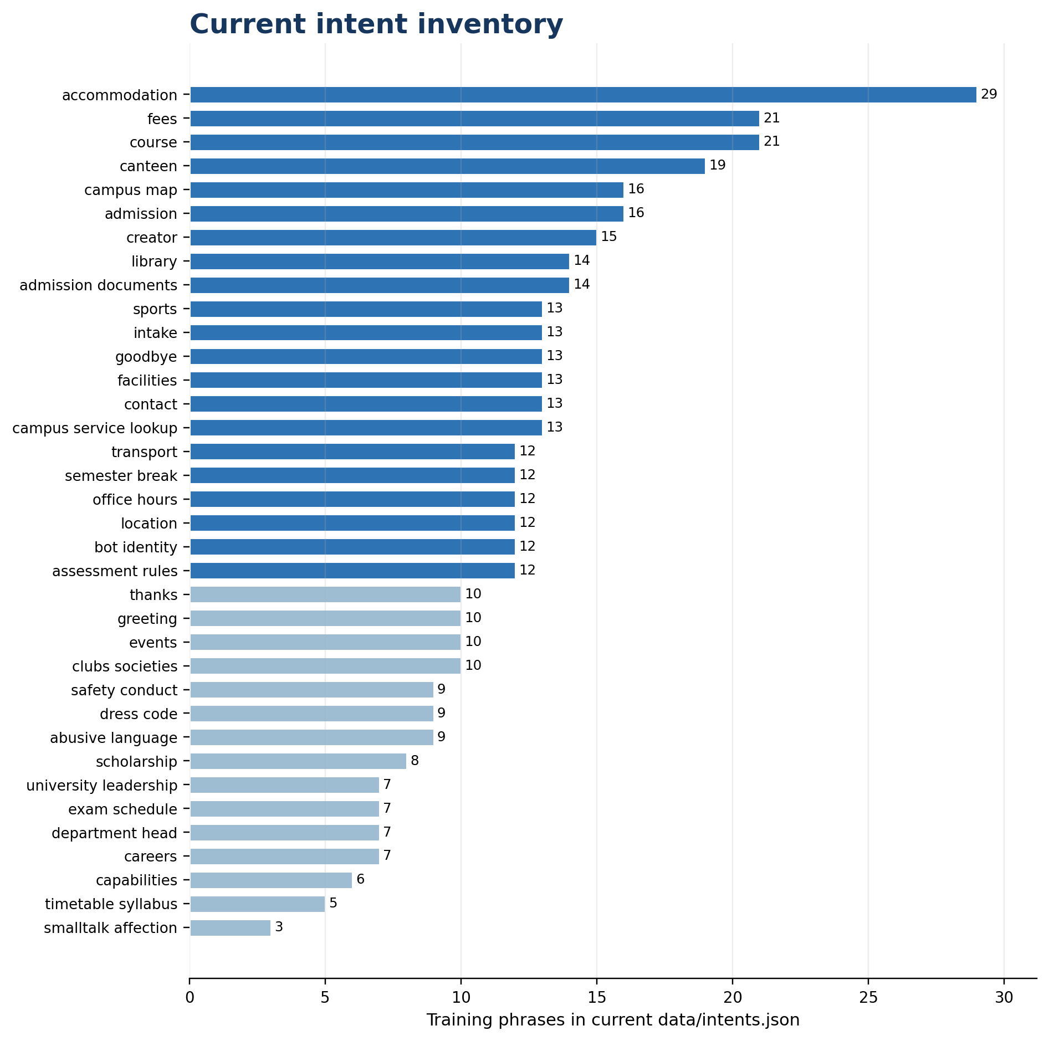
Figure 2: Distribution of raw training phrases across the current intent inventory

3.4 Preprocessing and feature extraction
- Convert the query to lowercase.
- Remove bracketed text, URLs, HTML fragments, punctuation, and line breaks; preserve digits and alphanumeric course codes because years, fees, and codes carry meaning.
- Split on whitespace and apply WordNet lemmatisation with a safe fallback when the resource is unavailable.
- Transform cleaned text into sublinear character-boundary TF-IDF features with analyzer = 'char_wb' and ngram_range = (3, 5), representing within-word fragments while respecting word boundaries.
- Retain stop words because character features and question words such as where, when, and how can distinguish university intents.
The preprocessing is deterministic and shared by the local classifier and local simulator. It is not asserted to be part of Google Dialogflow's cloud execution path.

3.5 Algorithms and member approaches

3.5.1 Member 1: Dialogflow ES configuration and local evaluation surrogate
Member 1's platform approach is represented by Dialogflow ES configuration artifacts, including intents, training phrases, entities where applicable, and controlled responses. The repository also contains DialogflowSimulatorClient, a transparent local pattern/Jaccard implementation used solely for offline, train-only evaluation. For each held-out query, it checks exact matches against training examples and otherwise selects the training pattern with the highest token-set similarity, with a small substring boost. This method is reproducible but is not Google's model and provides no evidence of cloud accuracy.

3.5.2 Member 2: TF-IDF and Logistic Regression
Member 2's deployed local classifier uses TfidfVectorizer(analyzer='char_wb', ngram_range=(3, 5), sublinear_tf=True) followed by LogisticRegression(C=30.0, max_iter=2000, random_state=42, class_weight='balanced'). The character-boundary representation captures within-word fragments and is more tolerant of minor spelling and inflection changes than the earlier word-only configuration. Exact cleaned training phrases receive confidence 1.0. Otherwise, the maximum class probability is compared with a confidence threshold of 0.20. Predictions below the threshold return fallback; during normal operation they may be logged to data/unrecognized_queries.json for human review. Evaluation disables logging so that the test procedure does not alter operational data.

3.5.3 Model-selection justification
Table 6: Three-fold out-of-fold model-selection comparison
Candidate | Accuracy at 0.20 | Weighted F1 at 0.20 | Coverage at 0.20 | Decision
Word TF-IDF (1–2) + LR C=10 | 0.6636 | 0.7351 | 0.7407 | Not selected
Character-boundary TF-IDF (3–5) + LR C=30 | 0.7874 | 0.8176 | 0.9019 | Selected
Word/character feature union + LR C=30 | 0.7710 | 0.8022 | 0.8902 | Not selected

Candidate selection used 3-fold stratified out-of-fold predictions with random_state = 42 and the recorded selection metric, deployment-threshold weighted F1. The selected character-boundary candidate records 0.8176 weighted F1 and 0.9019 coverage at threshold 0.20, improving the thresholded word-only candidate while remaining simpler than a feature union. Because the out-of-fold comparison covers the same canonical corpus used for subsequent development evaluation, the final held-out numbers should be treated as model-development evidence rather than a sealed external test.

3.5.4 Baselines
Multinomial Naïve Bayes with alpha = 1.0 and a unigram TF-IDF representation provides a probabilistic lexical baseline. Linear SVM with C = 0.1, max_iter = 1000, random_state = 42, and unigram TF-IDF provides a margin-based baseline. The baselines do not generate responses and are therefore N/A for BLEU/ROUGE.

3.6 Evaluation protocol and metrics
Table 7: Evaluation protocol
Control | Recorded setting | Rationale
Split | 80/20 stratified | Preserve class proportions where possible
Random seed | 42 | Repeatable partition
Training/test counts | 342 / 86 | Make sample size explicit
Text leakage check | 0 overlaps | Prevent cleaned duplicates across partitions
Member 1 scope | local simulator; training phrases only; not cloud | Prevent cloud-performance mislabelling
Member 2 threshold | 0.2 | Match the deployed confidence policy
Averaging | Weighted precision, recall, and F1 | Account for class support

Accuracy is the proportion of held-out queries assigned the expected label. Weighted precision measures the reliability of predicted labels, weighted recall measures recovered instances, and weighted F1 is their harmonic balance by class support. Coverage is the proportion receiving a non-fallback label; fallback rate is its complement for the thresholded systems.
For response quality, the protocol uses human-authored reference answers anchored to official TAR UMT sources. Corpus BLEU and mean ROUGE-1 F1 may be computed only after those references are independent of the candidate-selection templates. The repository currently contains 14 reference case(s), and the report uses only scores present in evaluation_results.json. The current evaluation artifact records the resulting scores for the member response engines; they are interpreted only as lexical-overlap evidence and not as proof of factual correctness.
For usability, Appendix C defines a five-point Likert instrument and open-ended questions. The verified feedback artifact currently contains 0 record(s). No respondent count, satisfaction percentage, or inferential claim is invented.

3.7 Validity, ethics, and data governance
- Construct validity: report weighted metrics with fallback behaviour; do not equate text overlap with factual correctness.
- Internal validity: check cleaned train/test overlap and restrict every local evaluator to training phrases.
- External validity: 86 held-out examples across many intents do not establish production performance.
- Cloud validity: the offline simulator does not validate Dialogflow ES; authentic console/API tests are required.
- Privacy: minimise survey fields and operational logs, redact identifiers, and control access.
- Factual currency: point time-sensitive answers to official sources and review them periodically.

4. Results and Discussion

4.1 Classification results
Table 8: Leakage-free held-out classification metrics from evaluation_results.json
Model | Engine/evaluation scope | Accuracy | Precision | Recall | F1
Member 1 (Dialogflow ES) | Local train-only Dialogflow-style simulator (not cloud) | 0.6163 | 0.6238 | 0.6163 | 0.5983
Member 2 (TF-IDF + Logistic Reg) | Deployed local ML; confidence threshold=0.20 | 0.7442 | 0.8275 | 0.7442 | 0.7626
Baseline 1 (Multinomial Naïve Bayes) | Local probabilistic baseline | 0.4651 | 0.5369 | 0.4651 | 0.4419
Baseline 2 (Linear SVM) | Local support-vector baseline | 0.7674 | 0.7651 | 0.7674 | 0.7459

Source: data/evaluation_results.json generated at 2026-08-24T18:02:56.633862. All classification metrics use the same recorded held-out split.
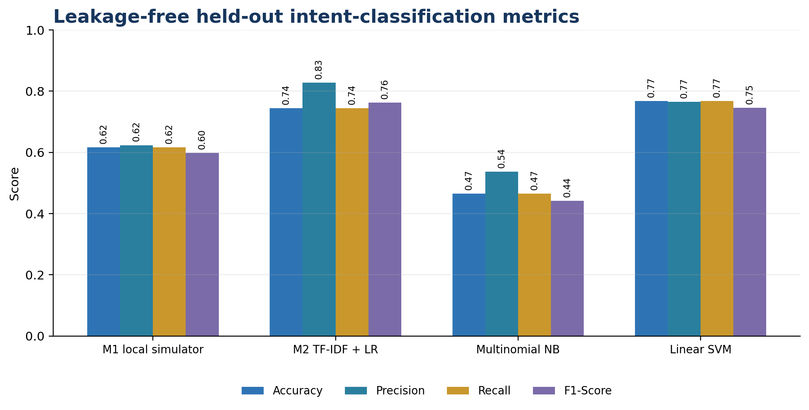
Figure 3: Held-out intent-classification performance by model
The strongest recorded accuracy is 0.7674 for Baseline 2 (Linear SVM). Member 2's local deployment configuration reaches 0.7442 accuracy and 0.7626 weighted F1. Member 1's local simulator records 0.6163 accuracy and 0.5983 weighted F1; this low score belongs to the train-only simulator and must not be re-labelled as Dialogflow cloud performance.
The result ordering suggests that a margin-based linear model currently generalises better than the other tested lexical approaches on the held-out phrases. Member 2's classifier is affected by both multiclass separation and its confidence gate. The comparison does not establish that a particular algorithm is universally superior; it reflects this split, preprocessing, feature configuration, and small class supports.

4.2 Coverage, fallback, and response-quality status
Table 9: Coverage, fallback, and response-quality evidence
Model | Coverage | Fallback | Text-overlap metrics | Evidence status
Member 1 (Dialogflow ES) | 0.9186 | 0.0814 | BLEU 0.1460  ROUGE-1 0.4086 | Independent reference test (14 cases); intent accuracy=0.7143; coverage=1.0000
Member 2 (TF-IDF + Logistic Reg) | 0.8721 | 0.1279 | BLEU 0.1689  ROUGE-1 0.4137 | Independent reference test (14 cases); intent accuracy=0.7857; coverage=0.9286
Baseline 1 (Multinomial Naïve Bayes) | 1.0000 | 0.0000 | BLEU N/A  ROUGE-1 N/A | N/A - no independent human-authored response reference set was provided
Baseline 2 (Linear SVM) | 1.0000 | 0.0000 | BLEU N/A  ROUGE-1 N/A | N/A - no independent human-authored response reference set was provided

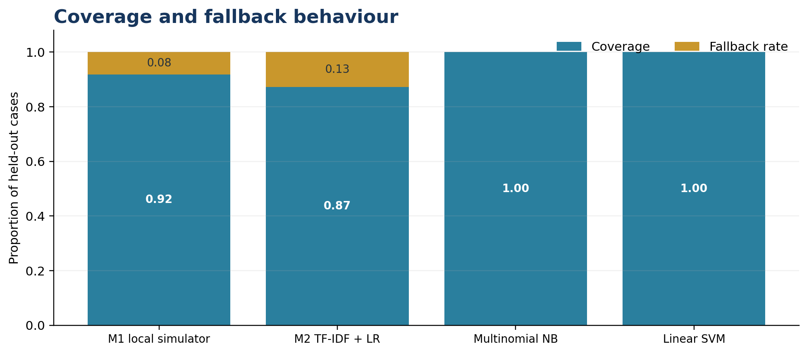
Figure 4: Coverage and fallback behaviour on the held-out set
Member 2 answers 87.21% of the held-out cases and falls back on 12.79%. A high fallback rate can be operationally safer than an unsupported confident answer. This remains a material usability cost that should be examined during threshold tuning. Threshold tuning must therefore be evaluated as a coverage–accuracy trade-off rather than optimised for one metric alone.

4.2.1 Authentic end-to-end prototype evidence
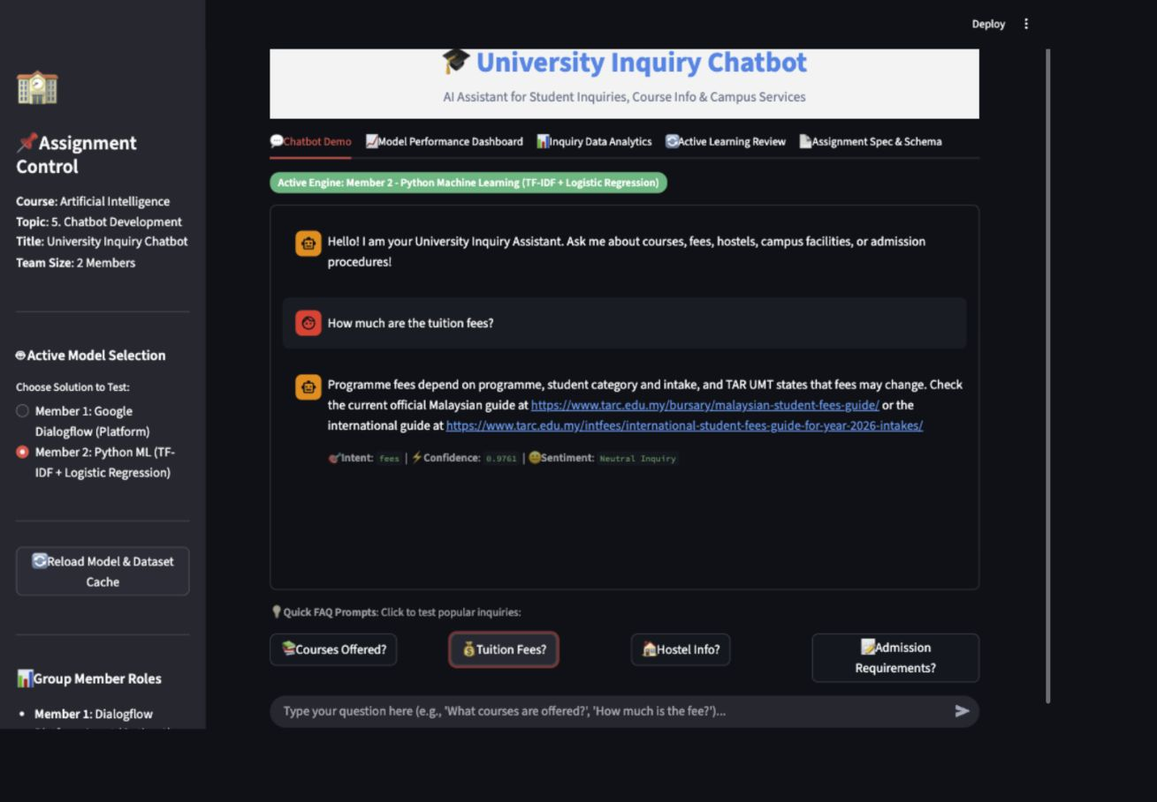
Figure 5: Authentic Streamlit end-to-end example using the Member 2 local classifier
This implementation artifact (file timestamp 2026-08-24T18:07:26+08:00) confirms that the final local route can accept a natural-language query, expose the active Member 2 engine, return the fees intent with confidence 0.9761, and provide official Malaysian and international fee-guide links. It is one successful demonstration case, not an estimate of overall accuracy; general performance is reported only from the held-out evaluation above.

4.2.2 Labelled end-to-end smoke probes
Table 10: Labelled local smoke-probe summary
Artifact | Queries | Member 2 local model | Member 1 local simulator | Timestamp
data/latest_test_results.json | 10 | 10/10 labelled probes passed | 10/10 labelled probes passed | 2026-08-24 18:02:40

These manually labelled probes are deterministic end-to-end smoke checks over selected queries. The column labelled Member 1 refers to the repository's local Dialogflow-style simulator, not the Google Dialogflow ES cloud service. A 10/10 smoke result verifies the tested cases only and is not a substitute for the held-out classification results in Table 8.

4.3 Confusion and error analysis
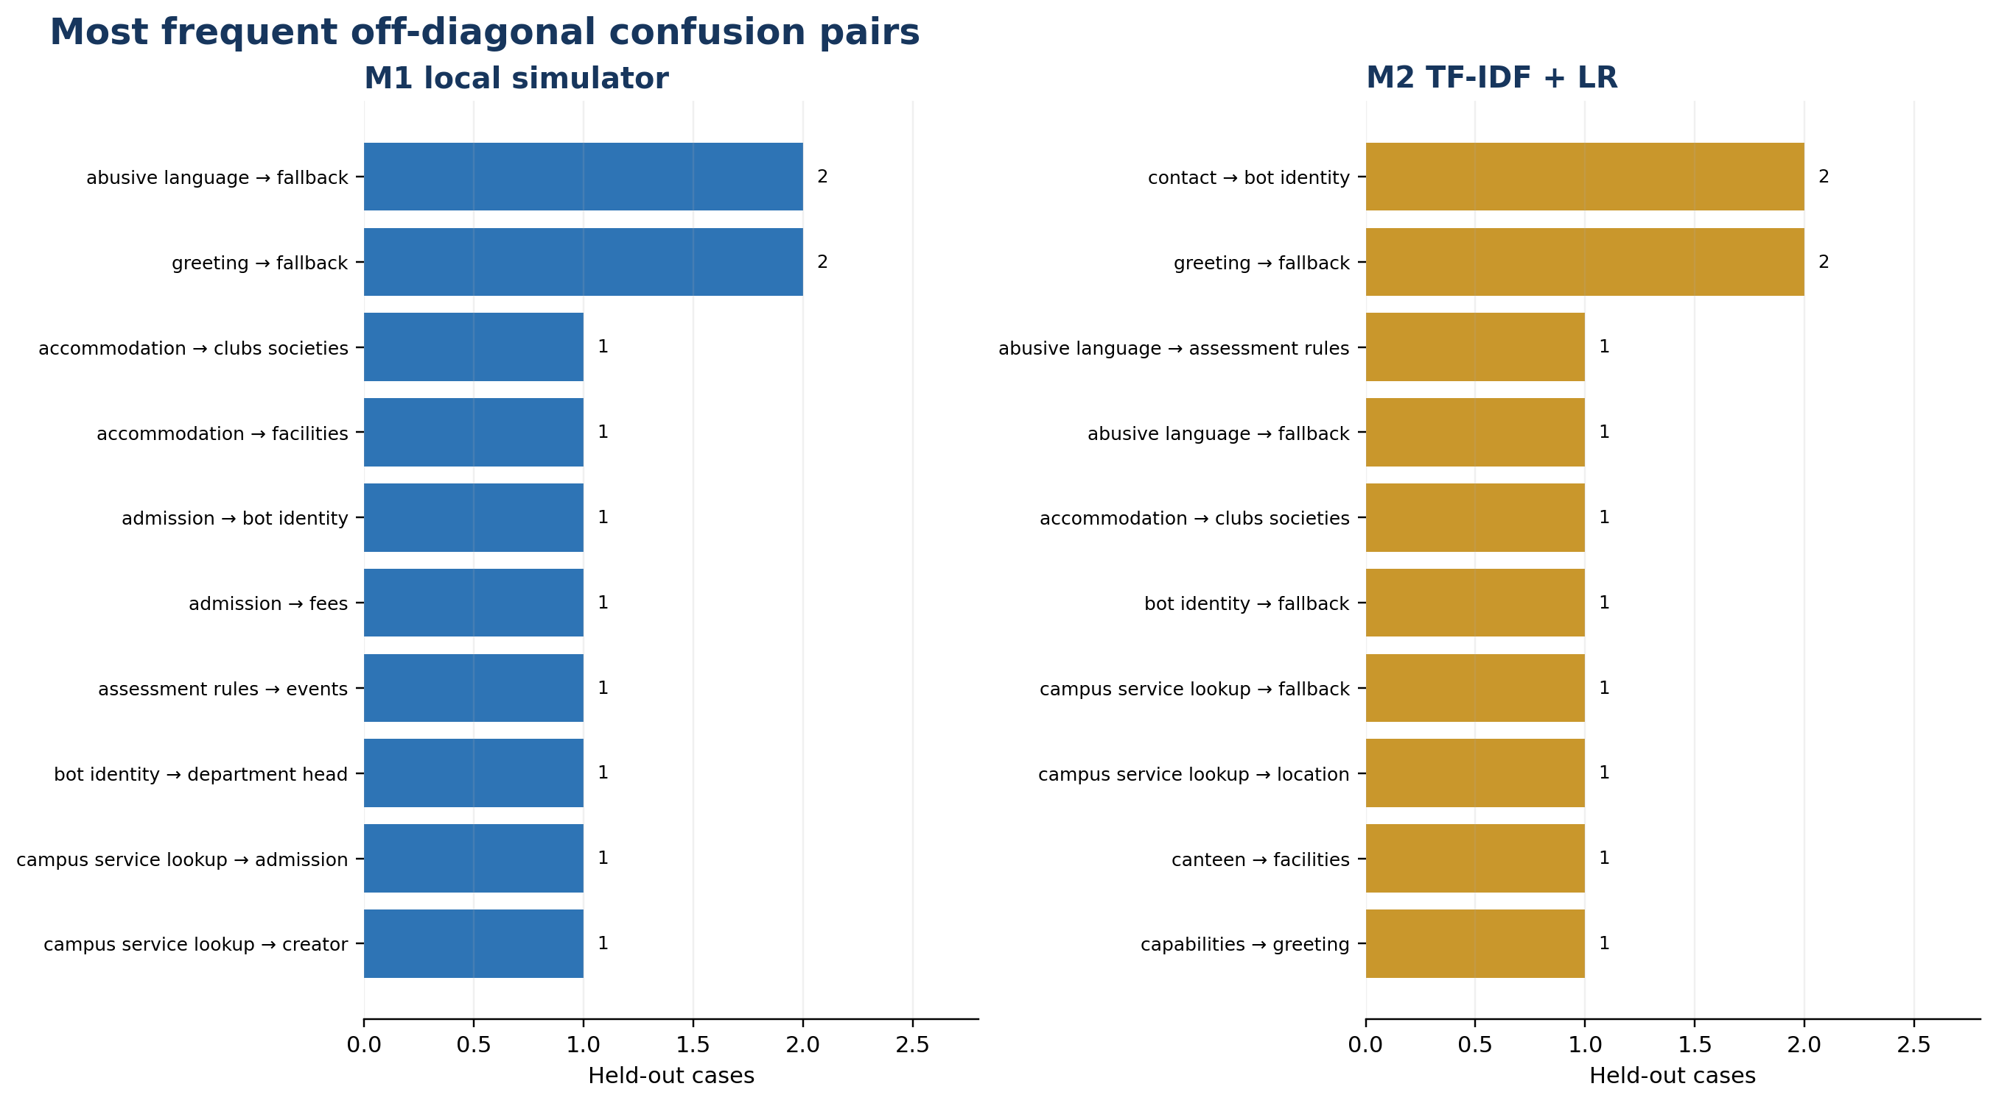
Figure 6: Most frequent off-diagonal confusion pairs for the two member approaches
Table 11: Error-analysis summary derived from recorded test cases
Model | Leading off-diagonal pairs | Fallback predictions
Member 1 (Dialogflow ES) | abusive_language → fallback (2); greeting → fallback (2); accommodation → clubs_societies (1); accommodation → facilities (1) | 7
Member 2 (TF-IDF + Logistic Reg) | contact → bot_identity (2); greeting → fallback (2); abusive_language → assessment_rules (1); abusive_language → fallback (1) | 11

Several errors are semantically plausible: location, campus map, contact, facilities, sport, intake, semester break, and examination questions share vocabulary. Short social utterances such as greetings, thanks, identity questions, and affection also offer few discriminating terms. These patterns imply that improvement should begin with label-boundary review and targeted paraphrase collection rather than indiscriminate duplication of existing phrases.
The confusion chart counts are small because the held-out set is distributed across many labels. A difference of one example can materially change a class score. Per-class support and repeated cross-validation would be needed before making stronger comparative claims.

4.4 Objective-by-objective interpretation
Table 12: Objective attainment
Objective | Finding | Status
FAQ coverage | 36 semantic intents in the current source inventory | Met at prototype scope
Two approaches | Dialogflow configuration track and local ML track are documented separately | Met; contribution evidence to confirm
Local implementation | Character-boundary TF-IDF (3–5), LR C=30/max_iter=2000/balanced, threshold=0.20 | Met
Leakage-free comparison | Recorded overlap=0; four model rows | Met for local evaluation
Cloud Dialogflow performance | No authentic cloud confusion matrix or API test artifact | Not yet demonstrated
Response-quality evidence | Independent reference test (14 cases); intent accuracy=0.7857; coverage=0.9286 | Measured
User satisfaction | 0 verified feedback record(s) | N/A; instrument supplied

4.5 Limitations and practical implications
- The evaluation snapshot is small relative to the number of intents and may be stale when intents.json changes.
- The Member 1 offline score measures a local pattern/Jaccard surrogate, not Dialogflow ES cloud NLU.
- The member approaches are not symmetric: Member 2 includes a confidence gate, while the baselines always classify; coverage must accompany accuracy.
- Template responses reduce hallucination but can become outdated and do not support rich multi-turn context.
- Automatic text-overlap metrics are available from the independent-reference instrument but still require human factuality and usability review.
- No verified participant study is available, so usability and satisfaction cannot be concluded.
Practically, the strongest next step is not to advertise the current prototype as accurate. It is to review the intent taxonomy, add independently phrased examples to weak labels, tune the confidence threshold on a validation set, rerun the leakage-free evaluation, and capture authentic Dialogflow test evidence. This sequence directly targets the observed errors and evidence gaps.

5. Conclusion, References and Sources

5.1 Achievements
The project has produced an end-to-end university FAQ chatbot prototype with a clear task scenario, a structured intent/response inventory, a Dialogflow ES configuration path, an offline Python classifier, a Streamlit interface, controlled fallback handling, test code, and a reproducible evaluation artifact. The documentation corrects the most consequential evidence risks by separating cloud configuration from the local simulator, reading all metrics from a leakage-free artifact, and refusing to invent response-quality or satisfaction results.
The present results establish a transparent baseline rather than a production claim. Baseline 2 (Linear SVM) has the highest recorded accuracy (0.7674), while Member 2's deployed configuration records 0.7442 accuracy with 0.8721 coverage. These figures provide a concrete starting point for error-driven improvement.

5.2 Limitations
The current system is single-turn, English-first, dependent on a small project-specific phrase set, and limited to predefined responses. Dataset and evaluation snapshots are not automatically synchronised unless evaluate.py and this builder are rerun in sequence. Dialogflow cloud accuracy has not been demonstrated by the offline surrogate. User satisfaction remains unavailable because the verified feedback file is empty. Response-overlap scores are available, but they do not establish factual correctness or usability.

5.3 Future work
- Resolve overlapping intent definitions and expand weak classes with genuinely new paraphrases collected under a documented protocol.
- Use a validation partition or nested cross-validation to tune the 0.20 threshold without optimising on the final test set.
- Evaluate class-balanced metrics, per-class support, calibration, latency, and repeated splits in addition to the current weighted metrics.
- Run an authentic Dialogflow ES console/API test on the same locked queries and preserve dated screenshots or JSON responses.
- Expand and review the independent-source response test, then pair BLEU/ROUGE with blinded human ratings for factuality, relevance, clarity, and source usefulness.
- Conduct the Appendix C survey with informed participation, report the actual response count and descriptive statistics, and retain anonymous raw responses.
- Add multi-turn context and a source-aware retrieval layer only after factuality, privacy, and update governance are defined.

5.4 References
Dibitonto, M., Leszczynska, K., Tazzi, F., & Medaglia, C. M. (2018). Chatbot in a campus environment: Design of LiSA, a virtual assistant to help students in their university life. In M. Kurosu (Ed.), Human–computer interaction. Interaction technologies (Lecture Notes in Computer Science, Vol. 10903, pp. 103–116). Springer. https://doi.org/10.1007/978-3-319-91250-9_9
Google Cloud. (n.d.). Dialogflow ES documentation. https://cloud.google.com/dialogflow/es/docs
Lin, C.-Y. (2004). ROUGE: A package for automatic evaluation of summaries. In Text summarization branches out (pp. 74–81). Association for Computational Linguistics. https://aclanthology.org/W04-1013/
Papineni, K., Roukos, S., Ward, T., & Zhu, W.-J. (2002). BLEU: A method for automatic evaluation of machine translation. In Proceedings of the 40th Annual Meeting of the Association for Computational Linguistics (pp. 311–318). Association for Computational Linguistics. https://doi.org/10.3115/1073083.1073135
Pérez-Soler, S., Juárez-Puerta, S., Guerra, E., & de Lara, J. (2021). Choosing a chatbot development tool. IEEE Software, 38(4), 94–103. https://doi.org/10.1109/MS.2020.3030198
Ranoliya, B. R., Raghuwanshi, N., & Singh, S. (2017). Chatbot for university related FAQs. In 2017 International Conference on Advances in Computing, Communications and Informatics (ICACCI) (pp. 1525–1530). IEEE. https://doi.org/10.1109/ICACCI.2017.8126057

5.5 Dataset, factual-source, and tool acknowledgement
The intent phrases and response templates are stored in data/intents.json and are treated as a team-curated project dataset, not a public big-data benchmark. Official TAR UMT URLs are used as factual anchors for the independent response-quality instrument. Complete machine-readable case-to-source mappings are preserved in data/response_quality_test.json.
Table 13: Official factual-source inventory used by the response-quality instrument
Topic | Official URL | Repository provenance
Location | https://www.tarc.edu.my/contact-us/ | response_quality_test.json
Intake | https://www.tarc.edu.my/admissions/new-student/academic-calendar/ | response_quality_test.json
Fees | https://www.tarc.edu.my/apply-and-study/fees/malaysians-student-fees/ | response_quality_test.json
Fees | https://www.tarc.edu.my/intfees/international-student-fees-guide-for-year-2026-intakes/ | response_quality_test.json
Admission Documents | https://www.tarc.edu.my/admissions/application-and-enrolment-status-enquiry/ | response_quality_test.json
Accommodation | https://www.tarc.edu.my/dsa/content.jsp?cat_id=1210BF6A-BE89-49AC-B823-DC729888CB71&fmenuid=DCF6BB08-61CA-4FB4-9057-18913B3987C4 | response_quality_test.json
Accommodation | https://www.tarc.edu.my/admissions/faqs/ | response_quality_test.json
Library | https://library.tarc.edu.my/ | response_quality_test.json
Careers | https://scdcstu.tarc.edu.my/ | response_quality_test.json
Scholarship | https://www.tarc.edu.my/dsa/financial-aid/financial-aid/ | response_quality_test.json
Clubs Societies | https://www.tarc.edu.my/dsa/ | response_quality_test.json
Sports | https://www.tarc.edu.my/files/dsa/7BE77EC5-DA21-4AD7-92AE-3717934D5004.pdf | response_quality_test.json
Transport | https://www.tarc.edu.my/dsa/a/transportation/university-college-bus-service/ | response_quality_test.json
Assessment Rules | https://examination.tarc.edu.my/examination-services/faqs | response_quality_test.json
Setup/Documentation Source | https://cloud.google.com/dialogflow/es/docs/agents-settings | docs/dialogflow_setup.md
Setup/Documentation Source | https://cloud.google.com/dialogflow/es/docs/fulfillment-overview | docs/dialogflow_setup.md

Table 14: Software and artifact acknowledgement
Component | Recorded use | Repository evidence
Python | Application, model selection, evaluation, and document builder | app.py; model_selection.py; evaluate.py; tools/build_final_report.py
NLTK | Lemmatisation and optional BLEU token processing | src/preprocessing.py; evaluate.py
scikit-learn | TF-IDF, Logistic Regression, Naïve Bayes, SVM, metrics, split, cross-validation | src/ml_model.py; model_selection.py; evaluate.py; data/model_selection_results.json
Streamlit | Interactive prototype interface | app.py
Dialogflow ES | Platform configuration and integration track | dialogflow_agent.zip; docs/dialogflow_setup.md when present
Repository data | Intent patterns, feedback, tests, evaluation results | data/ directory

Appendix A. Contribution record and prototype evidence
Member verification required The responsibilities below reflect the repository's two-track structure. Both students must confirm the allocation and add dated evidence before submission; the report does not infer authorship from file names alone.
Table A1: Individual contribution record requiring member confirmation
Member | Proposed responsibility record | Evidence to attach | Confirmation
Member 1  [TO BE PROVIDED] | Dialogflow ES intent/entity/response configuration; exported agent artifact; train-only simulator integration; cloud validation plan | Export timestamp; version history; authentic console/API test; meeting log | Member initials/date: __________
Member 2  [TO BE PROVIDED] | NLTK preprocessing; character-boundary TF-IDF (3–5) + balanced Logistic Regression (C=30) pipeline; confidence gate; model selection; local evaluation and UI integration | Commit/version history; model-selection artifact; test output; code walkthrough; meeting log | Member initials/date: __________
Shared | Problem framing; dataset review; literature synthesis; error analysis; final QA and demonstration | Minutes, review notes, rehearsal checklist | Both initials/date: __________

Prototype demonstration evidence checklist
- ☐ Show a clean installation and launch of the Streamlit application.
- ☐ Demonstrate at least one correct local prediction, one ambiguous query, and one confidence-triggered fallback.
- ☐ Open the fallback log and explain human review without exposing personal data.
- ☐ Show the Dialogflow ES agent in the genuine console and test locked queries; retain dated screenshots or exported JSON.
- ☐ Run evaluate.py and explain the split, leakage check, metrics, coverage, and confusion errors.
- ☐ Each member presents and answers questions about their own implementation.
Screenshot policy Insert only screenshots captured from the real local application or authenticated Dialogflow console. No synthetic console image is included in this report. Record the capture date and a short description under each inserted figure.

Appendix B. Reproducibility checklist
After activating the project virtual environment, run the portable commands below from the repository root. Preserve the listed repository artifacts and check each item after a clean rerun.
Table B1: Reproducibility and submission checklist
Done | Area | Verification action
☐ | Environment | Install requirements.txt; record Python and package versions.
☐ | Dataset | Verify data/intents.json validates and record its phrase/intent counts.
☐ | Response references | Validate data/response_quality_test.json sources and independence.
☐ | Model selection | Run model_selection.py; confirm the three-fold OOF artifact and selected character-boundary candidate.
☐ | Evaluation | Run evaluate.py; confirm seed 42, stratification, and zero cleaned-text overlap.
☐ | Snapshot consistency | Confirm evaluation_results.json was generated after the final intents.json edit.
☐ | Tests | Run the full automated test suite and retain the terminal output.
☐ | Report | Run the command below to refresh charts and AI Report - Final.docx.
☐ | Visual QA | Render the DOCX with canonical render_docx.py and inspect every page.
☐ | Cloud evidence | Export the Dialogflow agent and capture authentic locked-query results.
☐ | Survey | If conducted, preserve anonymous raw responses and document consent/collection dates.

Regeneration commands
python model_selection.py
python evaluate.py
python -m unittest discover -s tests -v
python src/create_dialogflow_zip.py
python tools/build_final_report.py
Evaluation artifact: evaluation_results.json generated at 2026-08-24T18:02:56.633862. Builder output generated at 2026-08-24T18:17:09+08:00.

Appendix C. Planned user-satisfaction instrument
Status This is a survey instrument, not a result. data/user_feedback.json contains 0 verified record(s) at build time. Do not report a sample size or satisfaction statistic until genuine responses have been collected and checked.

Participant information and consent
Purpose: to assess whether the university inquiry chatbot is understandable and useful. Participation is voluntary. Do not enter names, student IDs, telephone numbers, or sensitive enquiry content. Responses are used only for this assignment. Participants may stop before submitting. By continuing, the participant confirms that they understand this information and consent to the anonymous use of their responses.

Task protocol
- Ask one course or programme question.
- Ask one fee, admission, calendar, or accommodation question.
- Rephrase one question using different wording or a minor typing error.
- Ask one deliberately out-of-scope question and observe the fallback.
- Follow any official source link supplied and judge whether it supports the answer.

Five-point ratings
Scale: 1 = strongly disagree, 2 = disagree, 3 = neither agree nor disagree, 4 = agree, 5 = strongly agree.
Table C1: User-satisfaction questionnaire
Item | Statement | 1 | 2 | 3 | 4 | 5
1 | The chatbot understood the intent of my in-scope questions. | ○ | ○ | ○ | ○ | ○
2 | The answers were relevant to the questions I asked. | ○ | ○ | ○ | ○ | ○
3 | The answers were clear and easy to understand. | ○ | ○ | ○ | ○ | ○
4 | The fallback message was appropriate when the chatbot was uncertain. | ○ | ○ | ○ | ○ | ○
5 | The interface was easy to navigate. | ○ | ○ | ○ | ○ | ○
6 | The response time was acceptable. | ○ | ○ | ○ | ○ | ○
7 | Official source links, when provided, were useful. | ○ | ○ | ○ | ○ | ○
8 | I would use this chatbot as a first step for common university enquiries. | ○ | ○ | ○ | ○ | ○
9 | Overall, I was satisfied with this prototype. | ○ | ○ | ○ | ○ | ○

Open-ended questions
- Which question, if any, did the chatbot misunderstand?
- Which answer was least useful or appeared outdated?
- What is the single most important improvement?
- Optional participant category: prospective student / current student / staff / other / prefer not to say.

Planned analysis
Report the exact number of valid responses, item-level counts, medians, interquartile ranges, and clearly labelled means only if appropriate. Do not convert ratings into a satisfaction percentage without a predeclared rule. Summarise open comments by theme without publishing identifying text. Separate exploratory feedback from formal conclusions and retain the anonymous raw data file.

Data-quality and exclusion rules
- Exclude test submissions created by the development team unless they are explicitly labelled as pilot data.
- Exclude blank responses and exact duplicate submissions after documenting the rule and retained count.
- Do not exclude a low rating merely because it is unfavourable; record any technical failure reported by the participant.
- Preserve the collection start/end dates, questionnaire version, invitation method, and final valid-response count.
Table C2: Minimum anonymous feedback-data schema
Field | Purpose | Example format
response_id | Anonymous deduplication key | random code; no student ID
submitted_at | Collection audit trail | ISO date/time
participant_category | Descriptive subgroup only | prospective/current/staff/other/prefer not
q1–q9 | Individual Likert responses | integer 1–5
open_comment | Improvement evidence | optional free text; redact identifiers
questionnaire_version | Instrument traceability | for example, v1.0

Appendix D. Authentic evidence register
This register distinguishes captured local evidence from artifacts still required. Cloud rows remain pending because a local simulator or synthetic image cannot validate Dialogflow ES.
Table D1: Evidence register for final submission
Evidence ID | Required artifact | Minimum metadata | Status
E1 | Streamlit home/interface screenshot | File timestamp 2026-08-24T18:07:26+08:00; Member 2 selection visible | CAPTURED
E2 | Local correct-intent interaction | Tuition-fee query; fees intent; confidence 0.9761; official-source response | CAPTURED
E3 | Local fallback and review log | Query; threshold; safe redaction; timestamp | TO BE CAPTURED
E4 | Dialogflow ES intents view | Authenticated console; agent name; capture date | TO BE CAPTURED
E5 | Dialogflow locked-query test | Query set ID; intent; confidence; API/console provenance | TO BE CAPTURED
E6 | Evaluation/test terminal output | Command; timestamp; test count; pass/fail | TO BE CAPTURED

E1/E2 artifact: report_assets/app_chatbot_e2e.png. Figure 5 reproduces it without alteration.
Do not substitute The local Dialogflow-style simulator is not an acceptable substitute for E4 or E5. Likewise, a sample feedback file is not evidence of real participants.

Appendix E. Plagiarism Statement Form — Member 1
Complete this form personally. The document builder intentionally leaves all identity, signature, and date fields blank.
Table E1: Member 1 identification
Field | To be completed by the student
Name | [TO BE PROVIDED]
Student ID | [TO BE PROVIDED]
Course code | BMCS2003
Assignment title | TAR UMT University Inquiry Chatbot
Tutorial group | [TO BE PROVIDED]

Declaration
I declare that the work submitted for this assignment is my own contribution except where sources and team contributions are clearly acknowledged. I have not copied another student's or group's work, shared material in a way that enables academic misconduct, fabricated research participants or results, or represented generated or third-party material as my own without appropriate acknowledgement. I understand that I remain responsible for checking the accuracy, originality, citations, data provenance, and submitted code.
- ☐ I have reviewed the final report and source code.
- ☐ I have checked that my individual contribution record is accurate.
- ☐ I have checked that all reported metrics are traceable to evaluation_results.json or clearly labelled N/A.
- ☐ I have complied with TAR UMT academic-integrity requirements and the instructions supplied for this assignment.
Student signature: ______________________________________________
Date: __________________________________________________________
Witness / tutor (if required): ____________________________________
Unsigned by design No name, signature, date, or consent is inserted automatically. The student must complete and sign this form after reviewing the final submission.

Appendix F. Plagiarism Statement Form — Member 2
Complete this form personally. The document builder intentionally leaves all identity, signature, and date fields blank.
Table F1: Member 2 identification
Field | To be completed by the student
Name | [TO BE PROVIDED]
Student ID | [TO BE PROVIDED]
Course code | BMCS2003
Assignment title | TAR UMT University Inquiry Chatbot
Tutorial group | [TO BE PROVIDED]

Declaration
I declare that the work submitted for this assignment is my own contribution except where sources and team contributions are clearly acknowledged. I have not copied another student's or group's work, shared material in a way that enables academic misconduct, fabricated research participants or results, or represented generated or third-party material as my own without appropriate acknowledgement. I understand that I remain responsible for checking the accuracy, originality, citations, data provenance, and submitted code.
- ☐ I have reviewed the final report and source code.
- ☐ I have checked that my individual contribution record is accurate.
- ☐ I have checked that all reported metrics are traceable to evaluation_results.json or clearly labelled N/A.
- ☐ I have complied with TAR UMT academic-integrity requirements and the instructions supplied for this assignment.
Student signature: ______________________________________________
Date: __________________________________________________________
Witness / tutor (if required): ____________________________________
Unsigned by design No name, signature, date, or consent is inserted automatically. The student must complete and sign this form after reviewing the final submission.

